Clinton Fire Department
Serving the Community Since 1926

Organizational Statement
2014 – 2015 – 2016

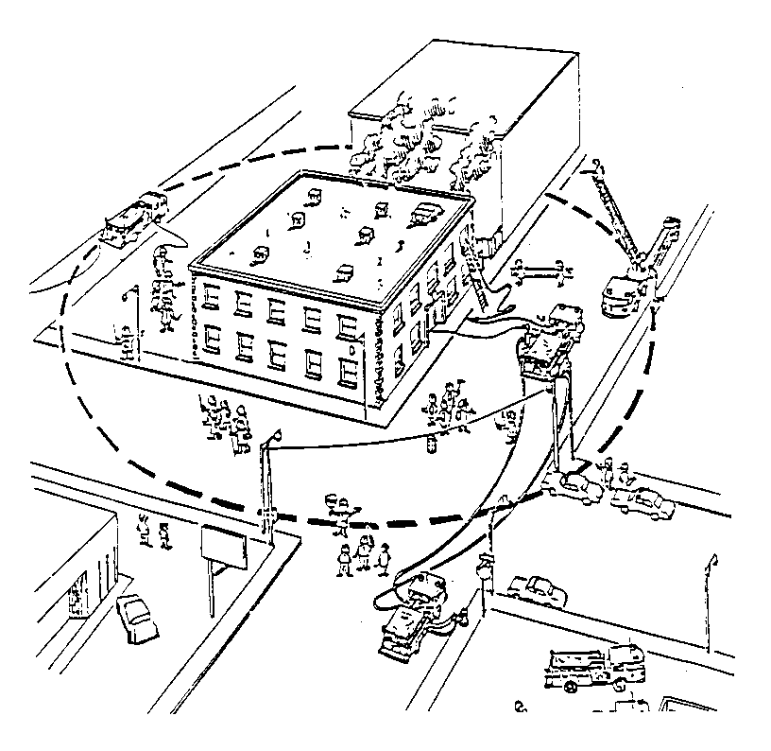
This Manual is the Property of the
Clinton Fire Department

Organizational Statement
2014 – 2015 - 2016
The following Organizational Statement has been written for the Clinton Fire Department of the Village of Clinton, Township of Clinton, County of Lenawee, County of Washtenaw and the State of Michigan.
Purpose:
This Organizational Statement has been designed to promote the safety, direction, organization, and welfare of department members, residents, and any person who may require the services of the Clinton Fire Department in the event of an emergency within the confines of the boundaries set forth for this department. This Organizational Statement shall also be in effect on all incidents while providing mutual aid within the scope of the mutual aid contracts in effect in Lenawee County, Washtenaw County and under the contract of MEMAC and MABAS agreements.

Article 01 – Services the Fire Department is authorized to perform
Article 02 – Commitment of the Department
Article 03 – Department Membership
Article 04 – Training required by Membership
Article 05 – Department Structure
Article 06 – Position of Fire Chief
Article 07 – Election of Fire Chief
Article 08 – Position of Officer
Article 09 – Position of Fire Fighter
Article 10 – Department Chain of Command
Article 11 – Department Programs
Article 12 – Incident Command System
Article 13 – Department Committee’s
Article 14 – Position Responsibility
Article 15 – Probationary Member
Article 16 – Department Training
Article 17 – Members access to State EMS Licensure
Article 18 – Record Keeping
Article 19 – Driver License Check
Article 20 – Back Ground Check
Article 21 –
Article 22 -
Article 23 –
Article 24 –
Article 25 -
Article 1

Services the Fire Department is authorized to perform
The Clinton Fire Department shall train and be equipped to perform the duties of the following with the authorization of the Clinton Village Council and the Clinton Township Board through the authorization of the Fire Board.

- Structural Fire Fighting – The activities of rescue, fire suppression, and property conservation involving buildings, enclosed structures vehicles, vessels, aircraft, or like properties that are involved in a fire or emergency situation.
- Wild land Fire Fighting – Open wild land, grass fires, field fires, or like properties.
- Emergency Medical Care – The provision of treatment to patients, including first aid, cardiopulmonary resuscitation, basic life support, advanced life support, and other medical procedures that occur prior to arrival at a hospital or other health care facility.
- Hazardous Material Response – First responders at the operational level at the site for the purpose of protecting nearby persons, property, or the environment form the effects of a release. The department shall comply with 29 CFR 1910.120 (OSHA).
- Water Rescue – The department at the open water and ice water rescue level shall for the purpose of protecting persons of our community shall perform at the level of the training perform by the department.
- Extrication - The department shall be trained in the extrication of victims for such objects as vehicles, machinery, and other objects encountered on incidents that the department is dispatched for.
- Weather Conditions not favorable - the department shall be trained in activities of responding to and watching for unfavorable weather conditions including weather watch and standby’s.
- Coverage of Community Events – Fall Festival, School Sporting Events, Community Parades, Memorial Day Events, Halloween Events, Christmas Events, and any other events authorized by the Fire Board.

Article 2

Commitment of the Department
The Clinton Fire Department is committed to safety in all aspects of the fire service and medical services, current and continuous training, new and updated technology and procedures, this shall be accomplished by hard work, dedication, organization, and a commitment to the NATIONAL FIRE PROTECTION ASSOCIATION (N.F.P.A.) 1500 Handbook, Standard on Fire Department Occupational Safety and Health Program, the Nation’s most authoritative comprehensive document on fire fighter safety. The Clinton Fire Department maintains a copy in the station for the use and knowledge of all members of this department.

Mission Statement
“The Clinton Fire Department is committed to the delivery of effective, courteous, and professional services through hard work, training, and leadership, while treating our citizens and employee’s with fairness, dignity, and respect.”

Risk Model
"We will risk a lot to save a lot" (lives),
in a highly calculated and controlled manner.
"We will risk a little to save a little" (property),
using the command system.
"We will risk nothing to save" (nothing),
Working inside a crew.
"We will never risk a not-involved customer to deliver our service",
Considerate of the people we meet on highways or incidents.

Vision Statement
Department Values – Take Enterprise View, Prioritize and Focus, Lead with Stretch Objectives, Be First to Implement.
Leadership Behavior – Treat our people as the most important resource we have in our Department, Role Model desired team behaviors, Lead to our vision with clarity, focus and a bias for action.
Team Behavior – Make our colleagues successful, Have open, honest, and candid dialogue, Trust and respect one another, Take time to develop relationships with one another, Learn from success and failure, Generate results- not activity, Be empowered- accountable and responsible.

Article 3

Department Membership
- All members shall reside within a reasonable distance of the fire station, at the discretion of the Fire Chief.
- Applicants for membership shall receive an application from the department or individual member. Each applicant shall fill out an application, take a medical approval form to be filled out by a doctor and returned to the department. Applicants shall follow the department Hiring Process and if applicant is approved for membership shall be on probation for a period no less than one (1) year.
- Applicants will have a criminal background check.
- The probationary member shall be showing an interest by starting his/her required state mandated training, if training has been available during this period.
- Each member shall review the Clinton Fire Department Operational & Training Manual that has been written for the purpose of informing a new member of department policies.
- Each member will be issued a full set of personal protective equipment, to include N.F.P.A approved helmet with 4” or 6” face shield, coat, bunker pants, boots, structural, leather work, and extrication gloves, helmet light, flashlight, utility rope with Carabineers, accountability tags, hood, goggles, safety glasses, SCBA mask with carrying bag.
- Each member will be issued a pager with charger. Each member will be connected to the phone notification system on their personal cell phone for alerting members of emergency calls, department and county announcements. Each member will be issued a portable radio on completion of all required training and has completed the probation period this radio also has the paging system.
- Each member will be assigned to a weekend crew and will be given assistance in learning the operations, responsibilities, equipment, and processes of the department.
- Each member shall complete the training and courses required in the first two (2) years of membership if courses are available as such. This shall be up to the discretion of the Fire Chief and/or Training Officer. The Fire Chief has the sole right to remove a member that is not fulfilling his/her department obligations. The member can be removed from department activities until requirements are fulfilled or removed from the department completely.
- Members are required to make 20 % of calls during each year.

Article 4

Training required by Membership

- The department shall establish training and attendance requirements for department personnel to ensure the highest quality service is provided
- To comply with the Department of Consumer Industry Services, Bureau of Safety and Regulation, MIOSHA, Bulletin 33, Part 74 for Firefighting, this written policy sets forth mandatory training in accordance with: Rule 7411. An Employer shall comply with all the following requirements:
- Provide training to an employee commensurate with those duties and functions that the employee is expected to perform. Such training shall be provided before the employee is permitted to perform emergency operations.
- An employer shall prepare and maintain a statement or written policy which establishes its basic organizational structure and which establishes the type, amount, and frequency of training to be provided to fire service personnel. The organizational statement shall be available for inspection by the director of the department of labor or his or her authorized representative and by an employee or his or her authorized representative.
- Rule 7451. Officers or employee in charge of emergency scene.
- Each Fire Department shall establish written procedures for emergency scene operations for an incident command system which shall apply to ALL employees who are involved in emergency operations. ALL employees who are involved in emergency operations shall be trained in emergency scene operations and the incident command system including (NIMS) National Incident Management System.
- The purpose of this policy, Firefighters are all Fire Department personnel who provide response to calls for service and have completed the minimum department training requirements, as specified in the appropriate Firefighter job description.
- For the purpose of this policy training sessions are those regularly scheduled training sessions conducted by the Clinton Fire Department.
- A total of 4 hours minimum will be offered each month to all personnel, of which personnel must attend 80 % of training to remain an employee of this Fire Department. The exception for 4 hours will be December and July. The department will attempt to make these hours up during other times of the year.
- Members will be encouraged to attend outside department training as well.
- Personnel shall attend all department training, however, it is realized that circumstances beyond the control of the individual will necessitate an occasional absence. It will be the individual fire fighters responsibility to complete make-up training as prescribed by the Fire Chief or Training Officer within the same month or quarter. Firefighters that fail to comply with this policy are subject to disciplinary action.
- Rule 7451. Supervisor or employee in charge of emergency scene.
- Each Fire Department shall establish written procedures for emergency scene operations for an incident command system which shall apply to ALL employees who are involved in emergency operations. ALL employees who are involved in emergency operations shall be trained in emergency scene operations and the incident command system including (NIMS) National Incident Management System.
- All fire department personnel who provide response to calls for service shall have completed the minimum department training requirements, as specified in the appropriate Firefighter job description.
- For the purpose of this policy training sessions are those regularly scheduled training sessions conducted by the Clinton Fire Department.
- Clinton Fire Department training sessions will include all mandated material such as HAZ-MAT, C.P.R., Medical First Responder, S.C.B.A., Search and Rescue, Fireground Tactics, Incident Command System, Apparatus Driver / Operator, The Care, The Use, Inspection, maintenance, and limitations of Protective clothing assigned, Infection Control, PASS, Eye Protection, Hearing Protection, Accountability System, Extrication, etc. However, this list is not meant to be inclusive.
- Training Officer (s) shall be appointed by the Fire Chief to assist the Fire Chief with department training. These members shall be qualified in the training subjects and delivery of department training.

Article 5

Department Structure
- The department shall consist of 30 full members and up to 3 probationary/reserve members, including Officers.
- Department Structure shall consist of the following:

(1) Fire Chief C-1
(1) Assistant Chief C-2
(1) Medical Captain C-3
(2) Crew Captains C-4, C-5
(1) Safety Officer Captain C-6
(1) Hazardous Material Captain C-7
(23) Fire Fighters Assigned numbers
(5) Explorers Assigned numbers

C. Department chain of command shall be determined by seniority being a consideration, training completed, ability to show leadership, knowledge of department operations, and ability to work with members in a TEAM effort.

Article 6

Position of Fire Chief
- The Fire Chief shall be voted to this position by a majority vote of all department members with voting rights. There shall be signup sheet posted on the Chief’s information board for ten (10) days prior to the vote. Any applicant with five (5) or more years of fire service and who has attained the Level of Fire Fighter II, Fire Officer I, II, & III, NIMS 100, 200, 700, 300, & 400. Incident Command System Certified Class, Emergency Medical Technician, and all other state and department training certification listed in department training requirements.

Article 7

Election of Fire Chief
- The Clinton Fire Fighter’s Association President, Vice President, Assistant Chief, and (2) two Fire Fighter’s shall collectively conduct the voting process and submit the results of the vote to the Village Council and Township Board who shall except or deny the results of the election through the process of the Joint Fire Board.
- This election process shall be accomplished by a written closed ballet with no less than five (5) association members and / or fire officers present for the vote count. The results shall be at least one more than half the votes present with 100 % of the membership voting to complete the process. All department members are encouraged to attend the vote count.
- In the event of the Clinton Fire Department not having a Fire Chief for whatever reason, the Assistant Chief shall assume the position until a new Chief is appointed. In the event that the Assistant Chief is unable to assume the position of Chief the Clinton Fire Board shall appoint a temporary Chief.

Article 8

Position of Officer’s
- The officer’s positions shall be appointed by the Fire Chief of the department by whatever means he/she feels is best for the department and the Fire Chief can make changes at anytime he/she feels it is in the best interest of the department to do so. All appointments and/or changes shall be reported to the fire board under the direction of the Village Council and Township Board.
- All appointments are for a one (1) year period and will be evaluated in March of each year by the Fire Chief.
- For appointment to an Officer’s position, a member shall have attained the following requirements; Fire Fighter I & II, Incident Command System Certified, MFR or EMT, and Officer I & II or agree to complete the Officer I & II within a reasonable time period and as offered or available. NIMS 100, 200, 700, 300, & 400.

Article 9

Position of Fire Fighter
- Firefighters will be hired by the department hiring process and will be on probationary status until all department criteria has been met and approval is granted by the Fire Chief.

Article 10

Department Chain of Command
- The Chief of the department with the input of the department Officers shall list and post a Department Chain of Command list that shall be evaluated annually.

Article 11

Department Programs
- The department shall write, adopt, and maintain the following programs. These programs will be maintained by the Fire Chief and Designees including Officers and Fire Fighters.

- Department Health & Safety Program
- Risk Management Program
- Risk Analysis Program
- Health & Safety Suggestion Program

Article 12

Incident Command System
- The Clinton Fire Department shall adopt and maintain an Incident Command System to guide the department at all incidents involving the department including but not limited to fire suppression, medical emergencies, hazardous material incidents, motor vehicle crashes, and/or rescue calls that we may be requested upon to mitigate.

- Incident Command System (ICS)
- Unified Command System (UICS)
- National Incident Management System (NIMS)

Article 13

Department Committee (s)
- The department shall organize and maintain the following committee’s to direct the department in its day to day operations as needed.

- Safety Committee
- Medical Committee
- Fire Prevention
- Accident or Near Miss Committee
- EMS Quality Control Auditors
- Training Committee
- Medical Control Representatives CFD
- Chaplain Committee
- Policies and Procedures Committee as needed

Article 14

Position Responsibilities (Fire Chief)
- Chief Fire Officer shall be responsible for these duties while holding this position.

- Planning and budgeting
- Communications
- Decision – making
- Directing and coordinating
- Controlling department matters
- Monitoring department activities
- Overseeing department as a whole
- Organization of the department
- Social and personal interface
- Professional development
- Attend Lenawee County Fire Chief Association Meetings
- Attend Washtenaw County Fire Chief Association Meetings
- All other meetings pertaining to the Fire Chief Position
- Lenawee County Medical Control Meetings
- Command Department Incidents
- Oversee Department Committees
- Oversee the safety of all department members
- Oversee the safety of the community
- Appoint Officers
- Oversee all department Officers and Fire Fighters
- Work with the Clinton Fire Board
- Work with Mutual Aid Departments
- Shall be assigned individual responsibilities as needed
- Attend department trainings, officer meetings, and officer trainings
- Respond all department calls when available
- Maintain a training attendance of 100% if possible
- Maintain a call attendance of 20% or higher

Position Responsibilities (Assistant Fire Chief)
- Assistant Chief shall be responsible for these duties while holding this position.

- Assist Chief in department matters
- In Command when Chief is not available
- Oversee the safety of all department members
- Fire Training
- Attend meetings when Fire Chief is not available
- Attend department Officers meetings and other required meetings when necessary
- Directing and coordinating
- Controlling department matters
- Monitoring department activities
- Overseeing department as a whole
- Organization of the department
- Social and personal interface
- Professional development
- Orientation of new members through Captains
- Shall be assigned individual responsibilities as needed
- Attend department trainings, officer meetings, and officer trainings
- Respond all department calls when available
- Maintain a training attendance of 100%
- Maintain a call attendance of 20% or higher

Position Responsibilities (Medical Captain)
- Medical Captain shall be responsible for these duties while holding this position.

- Assist Fire Chief in department Medical matters
- Responsible for all Members Medical Training
- Orientation (Medical) of new members through Captains
- Oversee Medical / Rescue responsibilities
- Attend department Officer Meetings
- Attend Medical Control Meetings as required by Fire Chief
- Maintain along with Fire Chief all required License (s)
- Maintain along with Fire Chief all members required certifications
- Attend Truck Checks
- Shall be assigned individual responsibilities as needed
- Attend department trainings, officer meetings, and officer trainings
- Respond all department calls when available
- Maintain a training attendance of 100%
- Maintain a call attendance of 20% or higher
- Maintain all required and needed policies and procedures through the Fire Chief

Position Responsibilities (Fire Captain)
- Fire Captain shall be responsible for these duties while holding this position.

- Assist Fire Chief in department matters
- Oversee the safety of all department members
- Oversee weekend duty crews
- Instruct crew members in learning of all department equipment
- Shall be assigned individual responsibilities as needed
- Shall be assigned individual responsibilities as needed
- Attend department trainings, officer meetings, and officer trainings
- Respond all department calls when available
- Maintain a training attendance of 100%
- Maintain a call attendance of 20% or higher

Position Responsibilities (Fire Fighter)
- Fire Fighter shall be responsible for these duties while holding this position.

- Assist Fire Chief and Officers in department matters
- Oversee the safety of all department members
- Attend Monthly Weekend Truck Checks
- Shall be assigned individual responsibilities as needed
- Attend department trainings
- Respond all department calls when available
- Maintain a training attendance of 90% or higher
- Maintain a call attendance of 20% or higher
- Assist in coverage of department and community events

Position Responsibilities (Probationary Fire Fighter)
- A Probationary Fire Fighter shall be responsible for these duties while holding this position.

- Assist Fire Chief, Officers, Firefighters in department matters
- Oversee the safety of all department members
- Attend Monthly Weekend Truck Checks
- Shall be assigned individual responsibilities as needed
- Attend department trainings
- Respond all department calls when available
- Maintain a training attendance of 90% or higher
- Maintain a call attendance of 20% or higher
- Assist in coverage of department and community events
- Only perform duties and tasks when directed and supervised by his/her FTO or Officer

Article 15

Record Keeping
- All records shall be kept and maintained by the officers of the department.

Article 16

Testing of Equipment
- Annual testing shall be performed by the department and or by a third party according to manufacturer recommendations.

Article 17

Truck Checks
- Truck checks shall be performed by maintaining two Duty Crews splitting the department into two crews. Truck checks shall be performed two times a month. Captains shall be in charge of crews under the discretion of the Assistant Fire Chief.

- Perform maintenance and checks of Apparatus, small equipment, tools, and building. (Fire Station)

- Truck checks shall be used for additional department training to include but not limited to Blood-borne Pathogens, Air-borne Pathogens, CPR & AED refreshers, drivers training, safety training, etc,.

Article 18

Members access to State Fire Training Records.
- Each member will be their state ID number and a password to enter into their state training records. A master list is kept by the Fire Chief.

- All above information will be kept in the black hiring book in the radio room next to the computer.

Article 19

Members access to State EMS Licensure
- Each member shall check their EMS Licensure status periodically throughout the three year licensing period. The department shall check and maintain a hard copy along with a copy of the member EMS license, CPR Card, and any other license held by that members.

- The Medical Captain will audit each members EMS credits throughout the year and inform each member of their status. It is also each members responsibility to track their progress.

Article 20

Drivers License Check
- The department shall track the driving activities of each member using the State of Michigan Driving Record Subscription Service. www.michigan.gov/sos

- The Fire Chief of the department shall perform this duty every three to six months. The Fire Chief is to be the only department member to access this information.

Article 21

Back Ground Check
- The department will obtain information on each member periodically during the duration of the Members employment on the department by using the State of Michigan OTIS System.

- The Fire Chief of the department shall perform this duty every three to six months.

Article 22
Article 23
Article 24
Article 25

AUTHORIZED BY: Dennis Keezer
Fire Chief: Clinton Fire Department
Date: July, 1994
Last Update: November 26, 2014

